{Lesson: Community Safety video title: community_safety_teen}
Script | On Slide Text | Animation Notes
[>>1]Hallo! Dit is goed om jou weer te sien! Die kursus gaan oor hoe om jou tiener veilig en gesond te hou en vandag leer ons van gemeenskapsveiligheid.  Een manier om jou tiener veilig te hou, is om saam 'n veiligheidskaart te skep. Saam kan julle die veilige en onveilige plekke in julle gemeenskap identifiseer.  Hier is drie stappe om jou te help om julle veiligheidskaart, saam met jou tiener, te skep:  [>>2]Teken[pause],[>>3] Besluit[pause], en  [>>4]Bespreek.  Kom ons leer meer saam!  [<<all] | [1]Gemeenskapsveiligheid  [2]TEKEN  [3]BESLUIT  [4]BESPREEK | {cues for on-screen text animation: >> means enter Left to right  << means exit right to left. Please time with speech as indicated.}
[>>1]Die eerste stap is om te TEKEN.  Saam met jou tiener, teken 'n padkaart van julle gemeenskap. Sluit in al die hoof plekke waarheen jy en jou tiener gaan, soos [2] jou huis, skool, strate, winkels, en enige ander plekke wat jou tiener besoek.  [<<all] | [1]TEKEN  [1]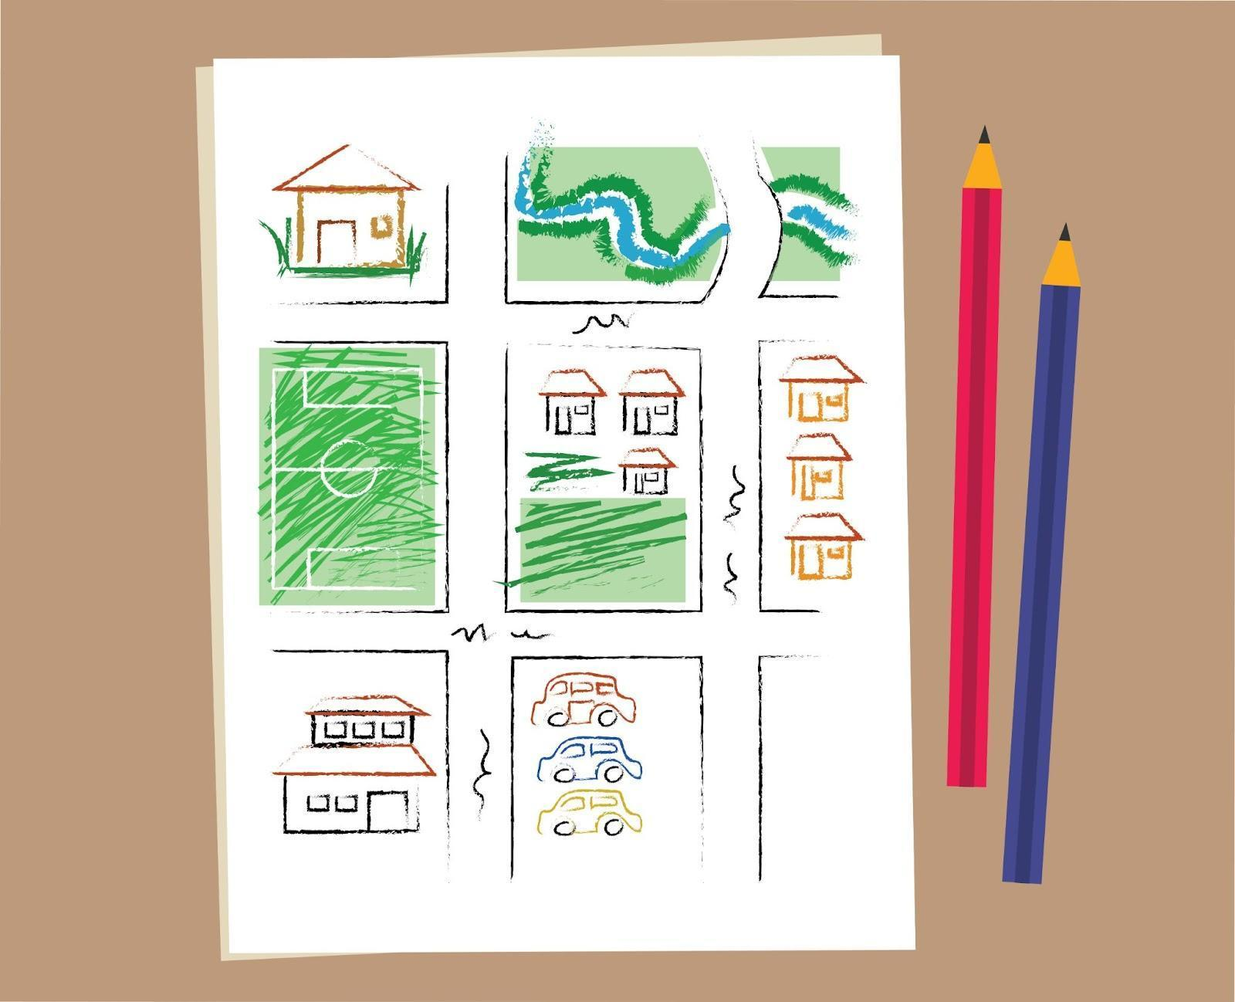 | {Begin with blank sheet (add white overlay over the drawing to show blank sheet of paper). At [2] the white shape fades out and reveals the drawing in the community_safety_draw. See reference video for example. }
[>>1]Die volgende stap is om te BESLUIT.  Praat met jou tiener oor die plekke op jou padkaart en besluit of hulle veilig is of nie. Onthou, laat jou tiener toe om hulle gedagtes te deel en luister na hulle. Hulle mag dalk meer weet as wat jy dink, oor plekke wat veilig en onveilig is! Wanneer julle besluit watter plekke veilig is vir jou tiener,[>>2] teken 'n sirkel om hulle. Dan, deurkruis enige plekke wat nie veilig is vir tieners nie. | [1]BESLUIT | {Begin with community_safety_draw on screen. Overlay community_safety_decide on [2]}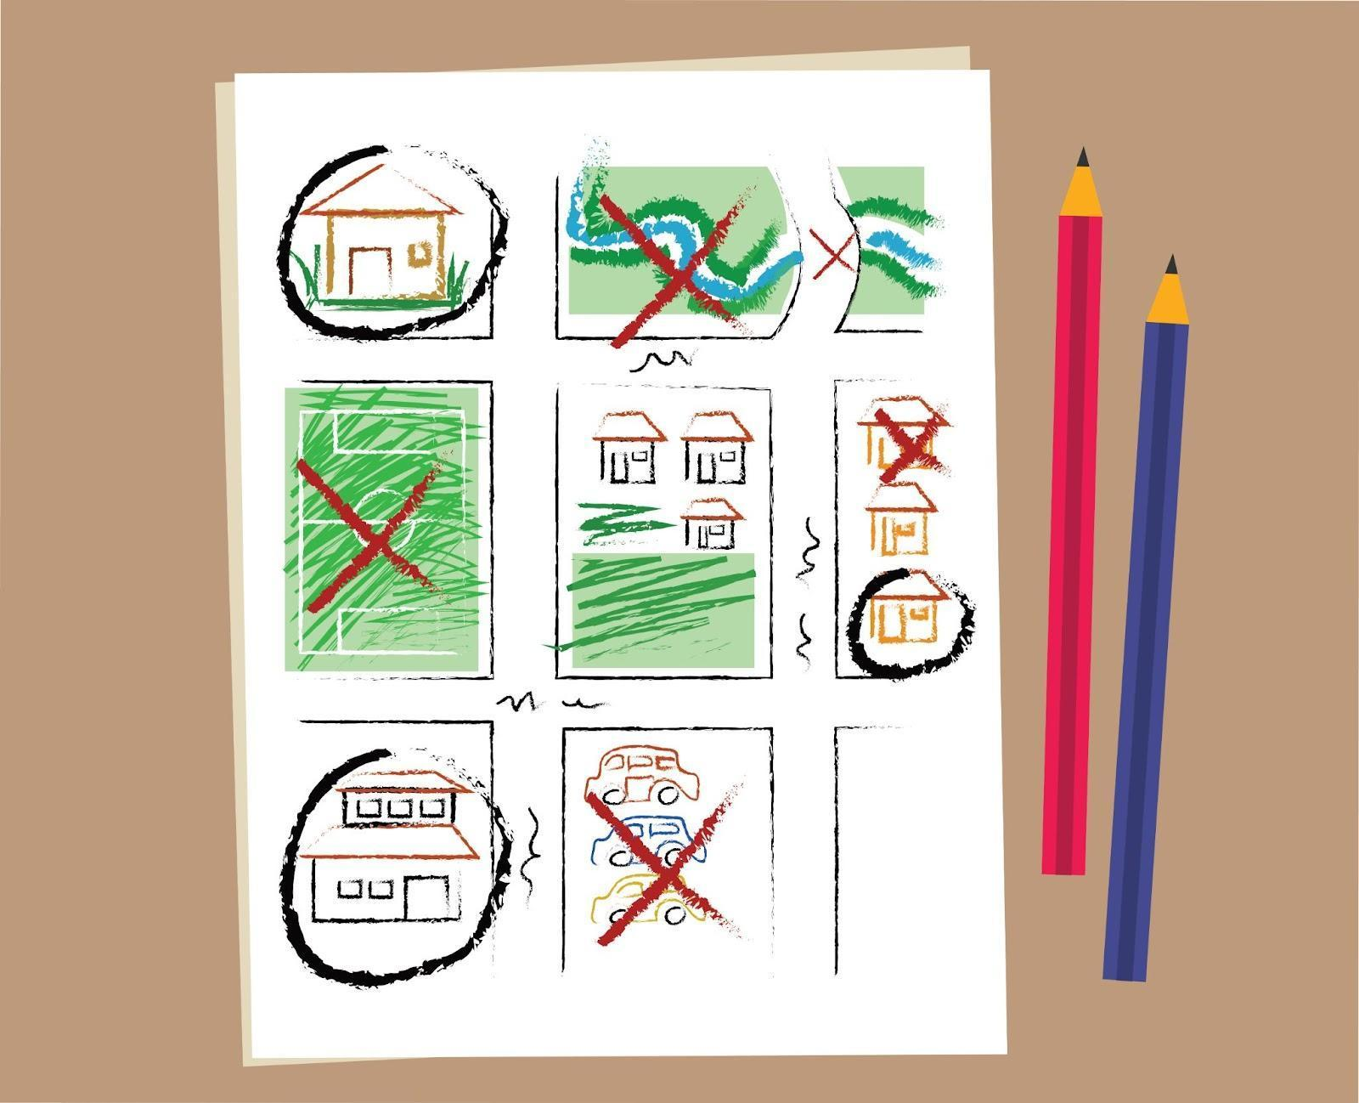
[>>1]Die finale stap is om te BESPREEK.  Soms, bevind ons onsself in moeilikheid. Bespreek waar jy en jou tiener ondersteuning kan kry in 'n krisis. Dit mag wees jou huis, skool, 'n polisiestasie, of 'n kliniek. [>>2] Merk die plekke duidelik met 'n ster op jou padkaart.  [<<all] | [1]BESPREEK   | {Begin with community_safety_decide. Overlay community_safety_discuss on [2]}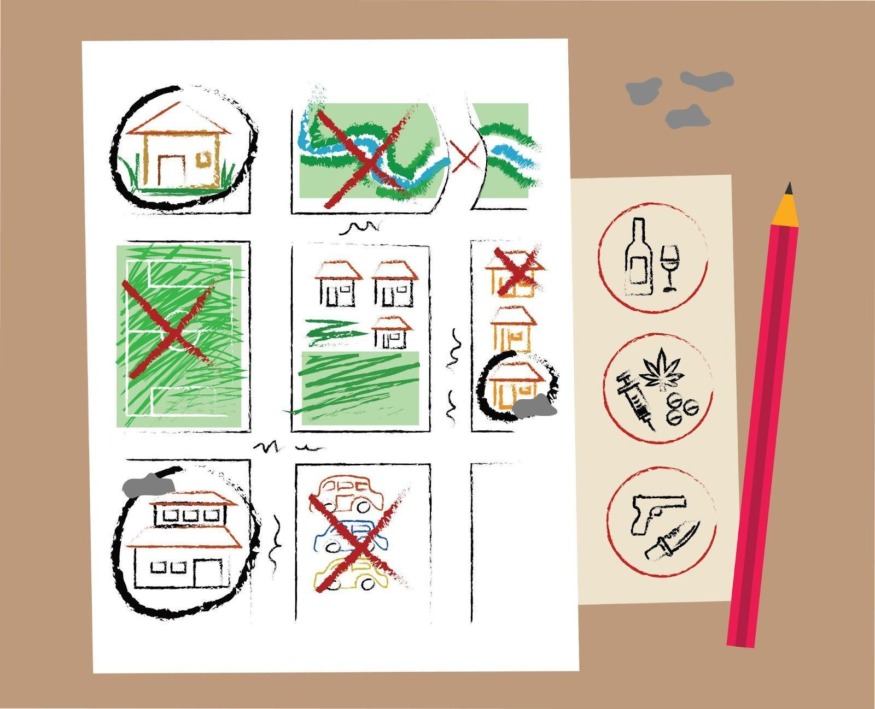
[>>1]Onthou, die drie wenke om 'n gemeenskapsveiligheidskaart te skep is  [>>2]teken, [pause][>>3] besluit[pause] [>>4]en bespreek.  Om oor veiligheid te praat met jou tiener is 'n klein manier om 'n groot verskil te maak. Herinner hulle dat hulle vir jou enige iets kan vertel oor iets onveilig wat gebeur het, sonder dat jy kwaad word. Dit sal jou help om vertroue met jou tiener te bou.  [<<1-4, >>5]  Jou tuisaktiwiteit is om 'n gemeenskapveiligheidskaart saam met jou tiener te skep. Het jy vandag tyd om dit te doen? | [1]Gemeenskapsveiligheid  [2]TEKEN  [3]BESLUIT  [4]BESPREEK  [5]Tuisaktiwiteit:  [5]Create a community safety map with your teen

{Lesson: Respond to Crises video title: crises_teen}
Script | On Slide Text | Animation Notes
[>>1]Welcome back! Today we are learning about how to respond to your teen in a crisis.  When our teens share something that is very hard or upsetting to them, we need to remember to stay calm, listen, and be open so that they feel supported.  Here are some things you can do to support your teen when they share something difficult with you:  [>>2]breathe, [pause][>>3]listen,[pause][>>4] respond [pause][>>5] and comfort.  Let’s learn more about these steps together. [<<all] | [1]Respond to Crises  [2]BREATHE  [3]LISTEN  [4]RESPOND  [5]COMFORT
[>>1] The first step is to breathe. [>>2]Stay calm. Ask yourself, “What does my teen need right now?”  While at first we might feel concerned, anxious or even angry, it’s important to remain calm and be there for your teen in the moment.  [<<1,2]  [>>3]] Next, listen. [>>4]Ask your teen what is going on and let them share with you what they need.. Notice what they are feeling and tell them what you notice so they feel heard.Remember to tell your teen you are there for them and love them.  [<<3,4]  [>>5]The third step is to respond. [>>6]What might help the situation? You might need to help your teen talk about their feelings or redirect their focus. Or you might need to discuss immediate actions to help them. You can give consequences later if needed.  [<<5,6]  [>>7]Finally, comfort your teen.[>>8] It can be hard to see your teen feeling upset or confused, but there is a lot you can do to support them. They need you to accept them and provide comfort when in difficult situations.  [<<7,8] | [1]BREATHE  [2]Remain calm.  [3]LISTEN  [4]Ask your teen what is going on.  [5]RESPOND  [6]What can help your teen right now?  [7]COMFORT  [8]Give your teen comfort.
[>>1]Remember, you can always type HELP to ParentText to receive a list of contacts in your community for crisis support. They may be able to help. [<<1] | HELP | {[1]Overlay image help_template}
[>>1]It can be difficult to see your teen feeling upset or confused, but remember that there’s plenty you can do to support them during a difficult time. Jy het dit, jy is so 'n wonderlike ouer!  [>>2-5]  Follow these steps whenever your teen shares something difficult. Supporting your teen through a crisis will also teach them how to support others in difficult times.  [<<all] | [1]Respond to Crises  [2]HAAL ASEM  [3]LUISTER  [4]REAGEER  [5]TROOS
[>>1]Vir jou tuisaktiwiteit, [>>2] Vind 'n kalm tyd om met jou tiener te praat oor moontlike krisisse wat kan gebeur.[>>3]Bespreek wat om te doen indien dit gebeur.[>>4] Herbesoek die Kartering Aktiwiteit om ander bronne van ondersteuning in die gemeenskap te identifiseer. [>>5] En bedank jou tienier dat hulle die tyd vat om oor dit te gesels.  Het jy tyd om dit vandag te doen? | [1]Tuisaktiwiteit:  [2] Praat met jou tiener oor moontlike krisisse.  [3] Bespreek wat om te doen indien dit gebeur.  [4] Herbesoek die gemeenskapsveiligheidskaart en identifiseer ander bronne van ondersteuning in the gemeenskap.  [5] Bedank jou teiner. | {Animate sentences to script either as bullets or in paragraph form. Overlay community_safety_discuss on [3]  If there is not space to have [2]-[5] on screen together, bring in [2] and [3] as indicated, then exit before bringing in [4] and [5].}  

{lesson: Prevent Sexual Violence video title:sex_violence_teen}
Script | On Slide Text | Animation Notes
[>>1]Welkom terug! Dit is wonderlik om jou weer te sien.  In vandag se les leer ons om seksuele geweld te voorkom. Dit kan moeilik wees om te dink dat jou tiener in 'n moeilike situasie kan wees, maar om hulle realiteit te verstaan en potensiale risiko's help ons om hulle veilig te hou.  We can help our teens know how to use their thoughts and voices in dangerous situations to stay safe. It makes a big difference!  In a dangerous situation, we may not know what to do and freeze or respond in an angry way – this is normal. These tools can help keep you and your teen safe: [>>2]know it,[>>3]see it, [>>4] and say it.  Let’s explore these together.[<<all] | [1]Prevent Sexual Violence  [2]KNOW IT  [3]SEE IT  [4]SAY IT
[>>1] First, know it. Know the difference between healthy and unhealthy relationships. [>>2}Remember, if you are attacked, it is never your fault. You are allowed to say and do what is needed to stay safe and get away – do not worry about what others may think. You are strong and powerful and deserve defending.[<<1,2]  [>>3] Next, see it. [>>4}When someone makes you (or someone else) feel uncomfortable with what they say or do, that is never okay! We all have the right to feel safe, especially at home. Follow your intuition. When you feel attacked with words or actions, your goal is to get away.  [<<3,4]  [>>5] Third, say it. Your voice can stop many attacks. [>>6] Be clear, confident, and direct. [>>7]Speak using your voice, body language, and eye contact. If you don't feel safe, you can do whatever it takes to get away.  [<<6,7]  Using your voice can look different in different situations. You could shout [>>8]"No!", [>>9]]call for help,[>>10] act strangely to confuse the attacker,[>>11] or negotiate.  [<<8-11]  [>>12]Here are some things you might say or shout to avoid a tough situation:  “I will call the police if you touch me again.”  “Do not touch my bum!”  “No lift for me, thanks! Last time I got a lift, I threw up!”  “I will give you my phone if you let me go.”  [<<12]  [>>13]Think about what you would do in the examples from this lesson. There is no wrong answer! | [1]KNOW IT  [2]Know that it is not your fault.  [3]SEE IT  [4]Recognize when you are unsafe.  [5]SAY IT  [6]Be clear,, confident and direct.  [7] Use your voice, body language and eye contact.  [8] “NO!”  [9] Call for help  [10]Act strangely  [11] Negotiate  [13] What would you do? | {[8] add a megaphone icon overlaid inline with the text ( after text) to emphasise shouting}  {[12] add emoji or simple line graphic icons/images to illustrate the sentence. Forexample, a blue police light or police car for sentence 1 which talks about the police}
[1]If you do get hurt by someone, remember it is never your fault. [2]Ask someone you trust for help, and make sure your teen knows they can tell you anything so you can find a solution together.  [<<all] | [1]It is not your fault.  [2]Ask a trusted adult for help | {keep [5] up}
[>>1]Remember, you can always type help to ParentText to receive a list of contacts in your community for crisis support. They may be able to help.[<<1] | HELP | {[1]Overlay image help_template}
[>>1,2]Your home activity is to help your teen be prepared by repeating this lesson together. To repeat this lesson type “PREVENT.” Can you do it today? | [1]Home Activity: [2]Type “PREVENT” and repeat this lesson with your teen.

{Lesson:Knowing Basics of Online Safety video title: online_safety_teen}
Script | On Slide Text | Animation Notes
Hallo daar! Today’s lesson is about how to keep your teen safe online.  Teens are spending a lot of time online. Om verbind te wees help hulle om positief te bly en meer te leer, maar daar is ook sommige risiko’s en gevare. Keeping your teen safe online is an important step to help them be part of the digital world.  Wanneer dit kom by aanlyn-veiligheid, is daar vier wenke wat jy in gedagte moet hou:  [>>2]learn,  [>>3]protect,  [>>4]build habits,  [>>5]and build trust.  There is so much to share that we will cover online safety over two lessons.  [<<4,5]Today, we are reviewing the tips [pause] learn [pause] and protect.  The next lesson will cover [pause] build habits [pause] and build trust.  Kom ons begin.  [<<all] | [1]Knowing Basics of Online Safety  [2]LEARN  [3]PROTECT  [4]BUILD HABITS  [5]BUILD TRUST | {Please refer to example video for additions of icons. }
[>>1]First, learn the dangers of being online:  [>>2]CONTENT: Your teen might come across harmful content or content you think is inappropriate for them, such as violence, aggressive language, or pornography. [<<2]  [>>3]CONTACT: Adults might pretend to be teens and ask for sexual pictures or to meet with your teen through an online platform.[<<3]  [>>4]CONDUCT: Sometimes, teens or strangers can say or do hurtful things online.[<<4,5] | [1]LEARN:  - [2]Content  - [3]Contact  - [4]Conduct
[>>1]Next, protect. Keep your teen safe online.  [>>2]Talk to your teen about which apps and websites are safe and which are not. Make sure to have a discussion about why! [<<2]  [>>3]Help your teen learn how to make strong passwords to protect their devices. [<<3]  [>>4]Teach your teen that they should keep personal information private, including photos or videos of themselves. What goes online stays online![<<1,4] | [1]PROTECT  - [2]Talk to your teen about safe apps  - [3]Help your teen learn about strong passwords  - [4]Tell your teen what should be kept private
[1]In the next session, we’ll continue learning about online safety. Today, your[<<1>>2]home activity is to ask your teen what they do to stay safe online. Jy mag dalk vind dat hulle klaar oor aanlyn-veiligheid dink. Praise your teen for any efforts they make. Can you talk with your teen today? | [1]Know Basics of Online Safety  Leer ✅  Beskerm ✅  Bou Gewoontes  Bou Vertroue  [2]Home Activity:  Ask your teen what they do to stay safe online

{Lesson: Build Habits and Trust Online video title: habits_online_teen}
Script | On Slide Text | Animation Notes
[>>1]Welcome back to ParentText ! This lesson continues our learning about keeping our teenren safe online.  Keeping your teen safe online is an important step to help them be part of the digital world.  [>>2,3,4,5]You already learned ways to protect your teen online with [<<2]learn and [<<3]protect in the previous lesson.  Today, we are learning how to build habits and build trust.  Are you ready to begin?[<<all] | [1]Build Habits and Trust Online  [2]LEARN  [3]PROTECT  [4]BUILD HABITS  [5]BUILD TRUST | {Please refer to example video for additions of icons. }
[>>1]The next step is to build habits. Skep veilige aanlyn-gewoontes by die huis.  [>>2]Plan phone-free times in your house, like during meals, homework, or in bed.  Set limits on the amount of time your teen spends online.  [3]Create rules with your teen about who they can chat with online. It is safest to only chat with people they already know. Hulle moet nooit persoonlike inligting in 'n kletskamer of met vreemdelinge deel nie.  [>>4]Before completing forms that ask for personal information, check that the web address begins with https://. Websites that begin with http:// may not be secure.[<<4]  [>>5]For older teens, you can help them create strong passwords for their accounts. Goeie wagwoorde is:  [pause][6] long  [pause] [7]do not include obvious personal information like your name or birthday;  [pause][8] and include upper and lower case letters, numbers and symbols.[<<5-8]  [>>9]Tell your teen not to click on pop-ups that ask them to download or pay for anything. | [1]BUILD HABITS  [2]Set phone-free times in your house  [3]Create rules for who to talk to online  [4]Check web addresses  https://  http://  [5]Set Strong Passwords:  [6]Long  [7]Don’t include personal information  [8]DO include upper and lowercase letters, numbers, and symbols  [9] Be careful of pop-ups | {Animate password details to explain better. See reference Video}
[>>1]Finally, BUILD TRUST with your teen  [>>2]Together, look at the websites, social media, games, and apps they use.  [>>3]Ask questions - this helps you learn more about your teen's interests!  [>>4]If you come across anything worrying together, talk about it with your teen. [>>5]If you need support, type HELP after you complete today’s lesson or any time you need extra support.  [>>6]Tell your teen that they should tell an adult if they feel scared, unsafe or upset about something online.  Teach your teen that if a stranger offers gifts, like virtual coins, in exchange for photos and personal information, and tells them to keep it a secret, they should tell you. | [>>1]BUILD TRUST  [2]Look at websites, social media, games and apps that your teen uses, together  [3]Ask questions  [4]Talk about worrying things together  [6]Tell your teen if they feel scared or unsafe, they should tell an adult | {[5]Overlay image help_template}
[>>1]Just as you keep your teen safe in the real world, you also need to make sure they are safe in the digital world. Deur hierdie stappe te volg, kan jy hulle beskerm en seker maak dat hul aanlyn-tyd veilig is, sodat hulle dit kan bly gebruik om te leer. Jy doen goed!  [<<1]  [>>2] Here’s something you can do with your teen today to start making sure they stay safe online:  [>>3]  First, have a conversation with your teen about how they can use the internet and devices in a safe way.  [>>4]  Volgende, praat dan oor watter webwerwe of toepassings onveilig kan wees. Bespreek hoekom.  [>>5]  Finally, praise your teen for how good they are at using the web!  Can you and your teen complete this task today? | [1]Build Habits and Trust Online  [2]Home Activity  [3]Have a conversation with your teen about how they can use the internet and devices in a safe way.  [4]Talk about which sites or apps might be unsafe and why?  [5]Praise your teen for how good they are at using the web safely!

